**DAILY ONLINE ACTIVITIES SUMMARY**

|  |  |  |  |  |  |  |  |  |
| --- | --- | --- | --- | --- | --- | --- | --- | --- |
| **Date:** | **19/05/2020** | | | | | **Name:** | **PONICA.J** | |
| **Sem & Sec** | **4TH & B** | | | | | **USN:** | **4AL18CS055** | |
| **Online Test Summary** | | | | | | | | |
| **Subject** | | **DAA** | | | | | | |
| **Max. Marks** | | **30** | | **Score** | | | **18** | |
| **Certification Course Summary** | | | | | | | | |
| **Course** | **INTRODUCTION TO PYTHON** | | | | | | | |
| **Certificate Provider** | | | **BRAIN O VISION** | | **Duration** | | | **90 MINS** |
| **Coding Challenges** | | | | | | | | |
| **Problem Statement:** Given an array of distinct integers. The task is to count all the triplets such that sum of two elements equals the third element. | | | | | | | | |
| **Status:EXECUTED** | | | | | | | | |
| **Uploaded the report in Github** | | | | | **YES** | | | |
| **If yes Repository name** | | | | | **https://github.com/ponica-jaya/LOCKDOWN-CODING.git** | | | |
| **Uploaded the report in slack** | | | | | **YES** | | | |

Online Test Details: (Attach the snapshot and briefly write the report for the same)

**Test was conducted from 9:15 to 9:55 am dated 19th may 2020 .The test include MCQ and predict the output kind of questions .**

**The above is the snapshot of the test conducted and analysis of the test was also provided by the service provider.**

Certification Course Details: (Attach the snapshot and briefly write the report for the same)

**Introduction to python is the certification course which I have choose to complete during this lock down period .Data science python is widely used and is a favourite tool along being a flexible and open sourced language.**

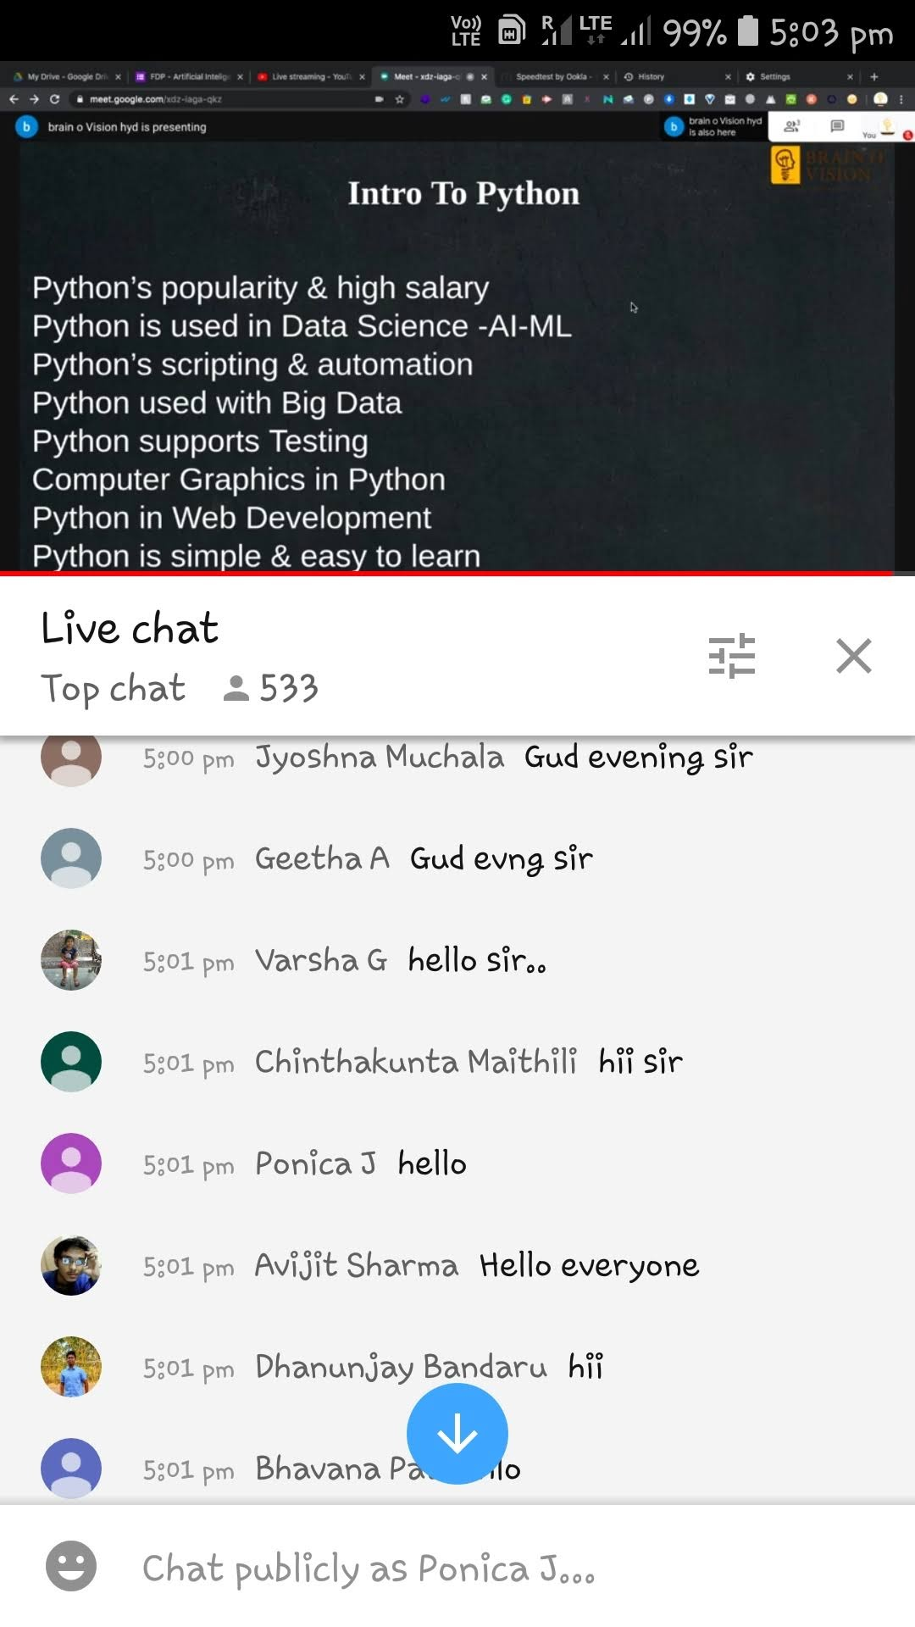

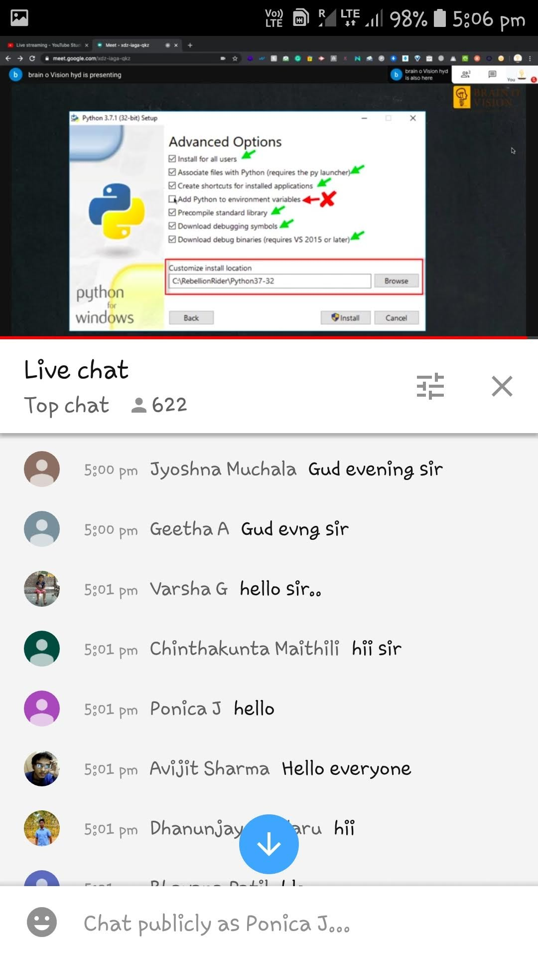

**the above is the snapshot of certification course.**

Coding Challenges Details: (Attach the snapshot and briefly write the report for the same)

**Everyday we are given with new question of coding related to the language of java and c. It seems interesting how we**

**imbibe ourself in depth to understand the logic break it and then code for it.**

**The below one is the snapshot of the github code that I have done.**

